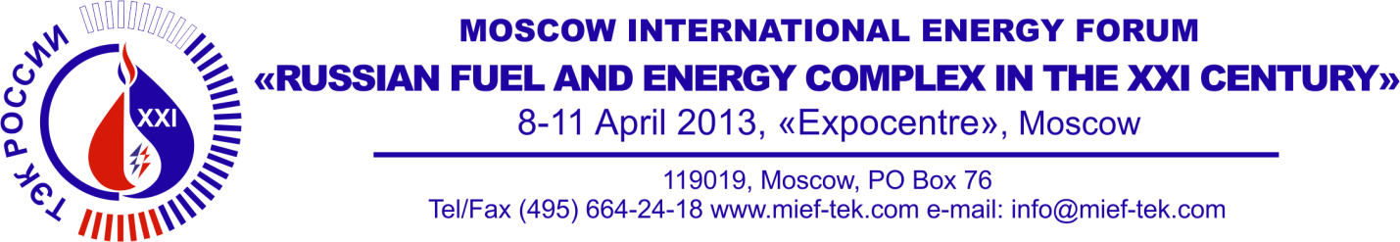

application form
for the catalogue of the Moscow International Energy Forum
”Russian Fuel and Energy Complex in the XXI Century”

Each participant registered to take part in the Forum/Exhibition shall provide Organizing Committee with the following information (in Russian and in English) to be placed in the catalogue:

- company name (including type of ownership)
- postal and location address (postal code, city, street, house number)
- contact telephone and fax number (including telephone country code)
- e-mail
- official web-site
- short information about company's activity - total scope about 4 lines (not more than 300 symbols, including gaps and punctuation marks)

Only generally accepted abridgements are allowed. Publication of additional information as well as advertisement shall be paid extra.

CONTACT INFORMATION

Company

Address
Phone
Fax
E-mail
Web-site
MEDIA’S ACTIVITY SUMMARY
(not more than 300 symbols, including gaps and punctuation marks)

